**European University of Lefke**

**University Management System**

*COMP 337 – Database management systems*

Group members:

174101 – Kristina Grigoryeva

174038 – Ayana Omarova

*2019 year*

**Contents**

**1. Introduction** 3

**1.1. Purpose** 3

**1.2. Functional Requirements** 3

**1.3. Non-Functional Requirements** 3

**2. Scenarios** 4

**2.1 Scenario 1** 4

**2.2. Scenario 2** 4

**2.3 Scenario 3** 5

**3. Site map** 6

**4. Sequence diagram** 7

**5. Entity relationship model** 8

**6. User interface** 9

**6.1 Index.php – main page** 9

**6.2 std.php – Student main page** 11

**6.3 ins.php – Instructor main page** 12

**6.4 fac.php – Faculty coordinator main page** 13

# **1. Introduction**

This web application specifies for different groups of people such as, students, instructors or faculty coordinators. They will have a controlled access to information and will make changes (creation/edition) in the database. The web application has been prepared using PHP, HTML/CSS and MySQL. Documentation consist of Entity Relationship Diagram, Sequence diagrams, Site Map and scenarios.

# **1.1. Purpose**

The main purpose of this Software design document is to provide a description of the design of the “University management system” to allow software development of the system to proceed with the understanding of how the system is to be built. This document explains the functional and non-functional requirements, and provides information about connection between web application and university database and appropriate actors’ actions.

# **1.2. Functional Requirements**

1. The system will provide appropriate information from the MySQL database.
2. The system must save inserted information from user to the database.
3. The system must log in users to the system according to the information provided by the user.
4. The system must change the password if user requests it.
5. The system must display users’ information and includes different functionalities.
6. User accounts are protected.
7. Password reminders and reset are handled by the website.
8. Authorized users can update the entity’s profile directly on the website.

# **1.3. Non-Functional Requirements**

1. The system must accommodate many users at the same time.
2. ­­The system must update data every 5 seconds.
3. The system is protected from unauthorized access to the system and its stored data.
4. The web application will be available for student, instructor and faculty coordinator in different ­pages separately; they do not have permission to access inappropriate page.
5. The system do not allow to duplication in the database.

# **2. Scenarios**

# **2.1 Scenario 1**

|  |
| --- |
| Type scenario : Student web account  Actor : User |
| Normal flow:   1. User types the username which starts from std… and password. 2. System searches these username and password in the database. 3. System opens web page which is called std.php and displayed to the user. 4. When the user clicks “change password”, the system opens new page which is called newpwd.php. This web page allows user to change password. 5. When the user clicks “log out”, the system opens new page which is called logout.php. This web page will close the session. |
| Alternative flows:  1.1* If user enters specific symbols such as (!@#$%^&*(())_+) and upper case letters, the system will erase this.  1.2* If user can not be found in the database, the system will show message “Incorrect username or password”  1.3* If user does not enter username or password, the system will show messages : “Please enter username” or “Please enter password”. |

# **2.2. Scenario 2**

|  |
| --- |
| Type scenario : Instructor web account  Actor : User |
| Normal flow:   1. User types the username which starts from ins… and password. 2. System searches these username and password in the database. 3. System opens web page which is called ins.php and displayed to the user. 4. User clicks the link “Register student to course”, the system will open “register.php” web page and user should choose the appropriate student id and course id and clicks “Save” button. This data will be inserted in the database. 5. When the user clicks “change password”, the system opens new page which is called newpwd.php. This web page allows user to change password. 6. When the user clicks “log out”, the system opens new page which is called logout.php. This web page will close the session. |
| Alternative flows:  1.1* If user enters specific symbols such as (!@#$%^&*(())_+) and upper case letters, the system will erase this.  1.2* If user can not be found in the database, the system will show message “Incorrect username or password”  1.3* If user does not enter username or password, the system will show messages : “Please enter username” or “Please enter password”.  4.1* If user chooses already inserted data, these data will not be inserted into the database. |

# **2.3 Scenario 3**

|  |
| --- |
| Type scenario : Faculty coordinator web account  Actor : User |
| Normal flow:   1. User types the username which starts from fac… and password. 2. System searches these username and password in the database. 3. System opens web page which is called fac.php and displayed to the user. 4. User clicks “student” link and the system will open “studentAdd.php”. User enters the preferable data as a name, surname, student id and chooses department. This data will be inserted in the database. 5. User clicks “course” link and the system will open “courseAdd.php”. User enters the preferable data as a course id, title, credits and chooses department. This data will be inserted in the database. 6. User clicks “teacher” link and the system will open “teacherAdd.php”. User enters the preferable data as a name, surname, instructor id and chooses department. This data will be inserted in the database. 7. User clicks “courses to teacher” link and the system will open “assign1.php”. User chooses the preferable data as a course id and instructor id. This data will be inserted in the database. 8. User clicks “instructor to student” link and the system will open “assign2.php”. User chooses the preferable data as a student id and instructor id. This data will be inserted in the database. 9. When the user clicks “log out”, the system opens new page which is called logout.php. This web page will close the session. |
| Alternative flows:  1.1* If user enters specific symbols such as (!@#$%^&*(())_+) and upper case letters, the system will erase this.  1.2* If user can not be found in the database, the system will show message “Incorrect username or password”  1.3* If user does not enter username or password, the system will show messages : “Please enter username” or “Please enter password”.  4-8* If user chooses already inserted data, these data will not be inserted into the database. |

# **3. Site map**

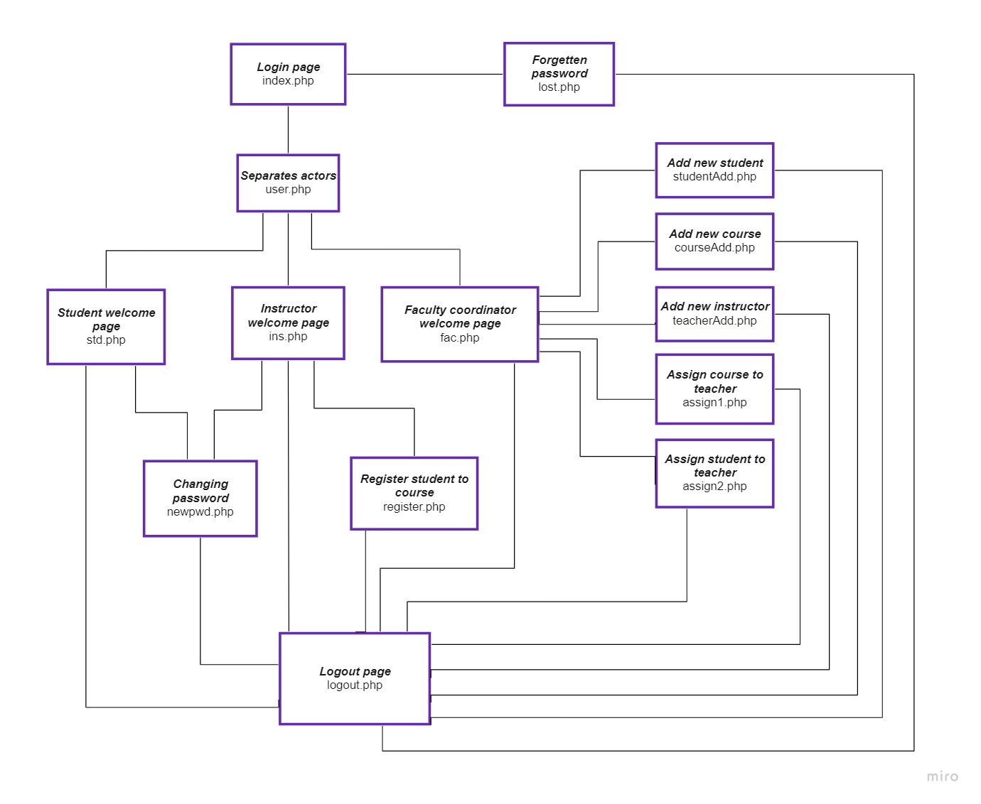

This site map is a representation of the content of web application, which include several files such as, index.php, user.php, std.php, ins.php, fac.php, register.php, assign1.php, assign2.php, courseAdd.php, studentAdd.php, teacherAdd.php, logout.php, lost.php and newpwd.php. In addition, it has config.php, which connects to the database. The main page of web application is index.php, which requests the users username and password, and defines the future actions, for example: if user enters the username as “std..”, the system will open std.php, with has the different functionalities. The web application has web site as a logout page, which are located almost in the every page. The system has high-level security, which restricts access after user close session.

# **4. Sequence diagram**

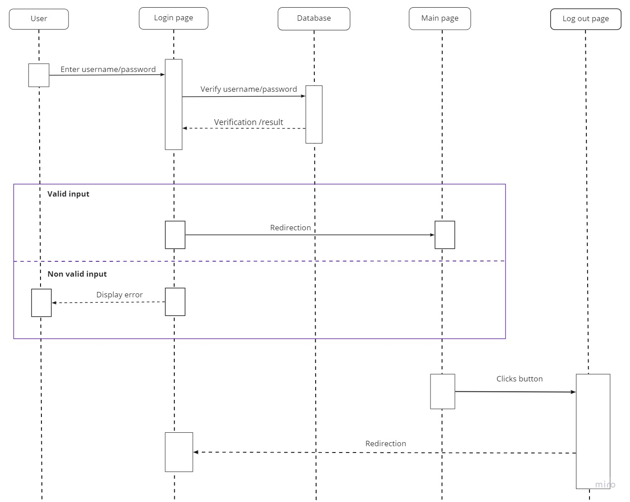

The diagram above shows all the processes which are required user login and logout actions. The user should login to the system in order to access the main page by entering appropriate information (username/password). The system pass users information to the database for verification. If users inserted valid information, the system will redirect to the main page. However, if users inserted invalid information which is not equivalent with the data in MySQL, the system will display message “Incorrect username or password”. When user are on the main page, he/she can logout from the main page by clicking the button “Log out”, and the system will redirect user to the login page.

# **5. Entity relationship model**

This model has eight entities sets such as, student, course, instructor, coordinator, login, department, takes and teaches:

1. Student( ID, fname, lname);
2. Course(course_id, title, credits);
3. Instructor(ID, fname, lname);
4. Coordinator(ID, fname, lname);
5. Login(user_name, password, email, status);
6. Department (dept_name, faculty);
7. Takes (ID, course_id);
8. 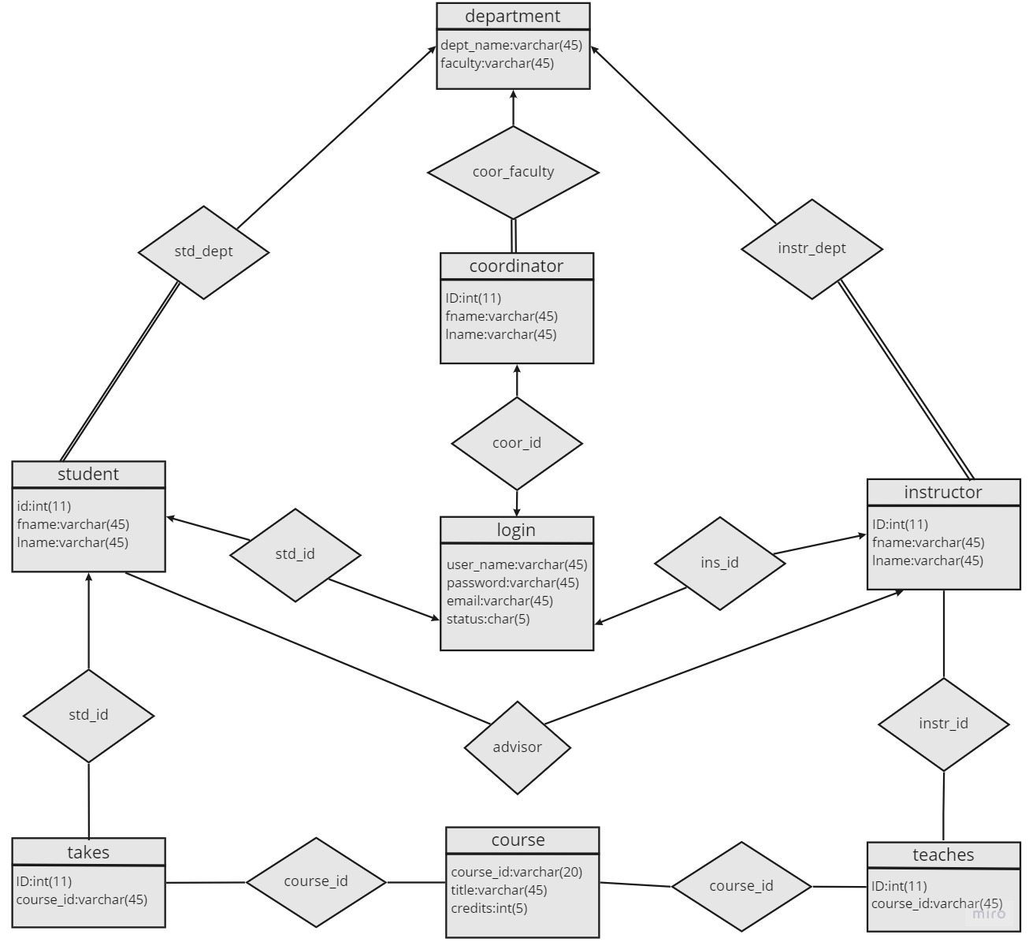Teaches (ID, course_id).

Relationship sets:

1. std_dept (student.dept_name = department.dept_name);
2. instr_dept (instructor.dept_name = department.dept_name);
3. coor_dept (coordinator.dept_name = department.dept_name);
4. std_id (student.ID = takes.ID);
5. instr_id (instructor.ID = takes.ID);
6. std_id (student.ID = login.ID);
7. instr_id (instructor.ID = login.ID);
8. coor_id (coordinator.ID = login.ID);
9. course_id (course.course_id = takes.course_id);
10. course_id (course.course_id = teaches.course_id);
11. advisor (s_ID = student.ID and i_ID = instructor.ID);
12. coor_faculty (department.faculty = coordinator.faculty).

# **6. User interface**

# **6.1 Index.php – main page**

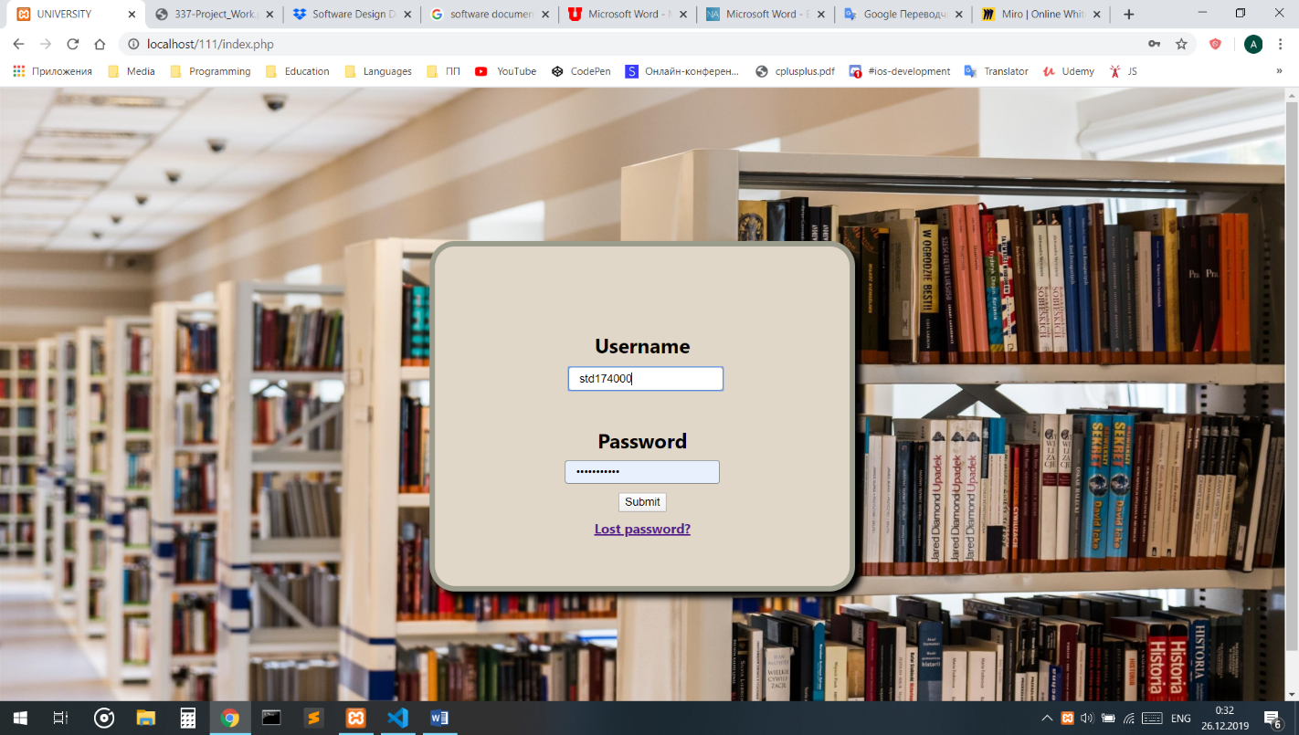

<form method="post" action="user.php">

    <div class="group">

        <label> Username </label>

        <br/>

    <input id="username" placeholder = "Username.." name="username" id="username" type="text" class="input" onkeyup="this.value = this.value.replace(/[^a-z0-9_-]/g, '')">

<div id="result"></div>

        <br/>

    </div>

    <div class="group">

        <label> Password </label>

        <br/>

    <input id="password" placeholder = "Password.." name="password" type="password" class="input" data-type="password" onkeyup="this.value = this.value.replace(/[^A-Za-z0-9]/g, '')">

       <br/>

    </div>

    <div class="group">

       <input type='submit' name='submit' value='Submit'>

       <br/>

    </div>

      <a href = "lost.php"> Lost password? </a>

      <br/>

</form>

The name = “username” will be used as an entering user ID in the future sessions. The “onkeyup” feature is using to restrict from inappropriate symbols (!@#$%^&* etc.), this also same for the password. When user clicks to the button “Submit”, the system will send inserted data in the user.php.

The system will check these username and password by database and define different users through “status” in “login” table in MySQL, then will send to the suitable php file(std.php or fac.php or ins.php). In order to secure password value in the database we use “md5” function.

session_start();

   include("config.php");

   if($_SERVER['REQUEST_METHOD'] === 'POST'){

    $user = $_POST['username'];

    $pass = $_POST['password'];

    $query = "SELECT * FROM `login` WHERE `user_name` = '$user' and `password` = md5('$pass')";

    $result = $conn->query($query);

    $_SESSION['username'] = $_POST['username'];

    $_SESSION['password'] = $_POST['password'];

    $sql = "SELECT * FROM `login` WHERE `user_name` = '$user' and `password` = md5('$pass')";

    $row = $result->fetch_assoc();

    if ($result->num_rows > 0){

      if ($row['status'] == 's') {

        header("Location:std.php");

      }

      else if ($row['status'] == 'i'){

        header("Location:ins.php");

      }

      else header("Location:fac.php");

    }

# **6.2 std.php – Student main page**

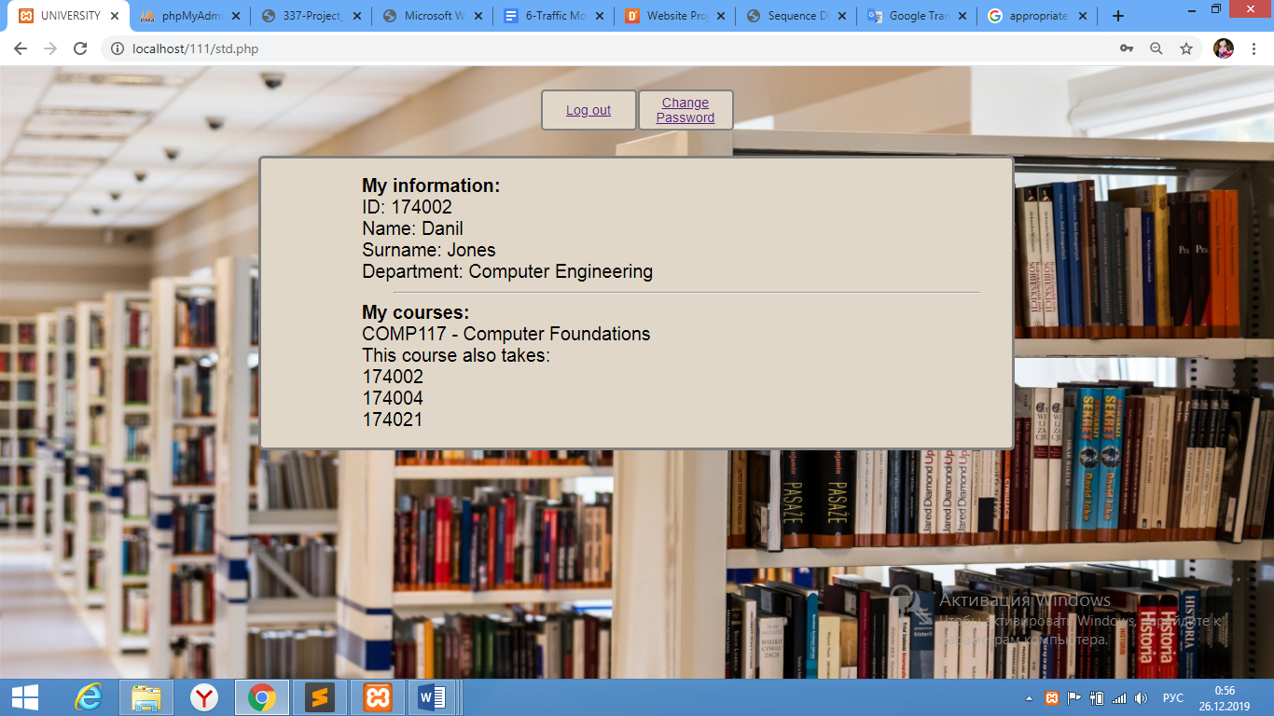

In this page student can see and update his/her details (change password); see the courses he/she is registered to; see the other students registered in his/her class. 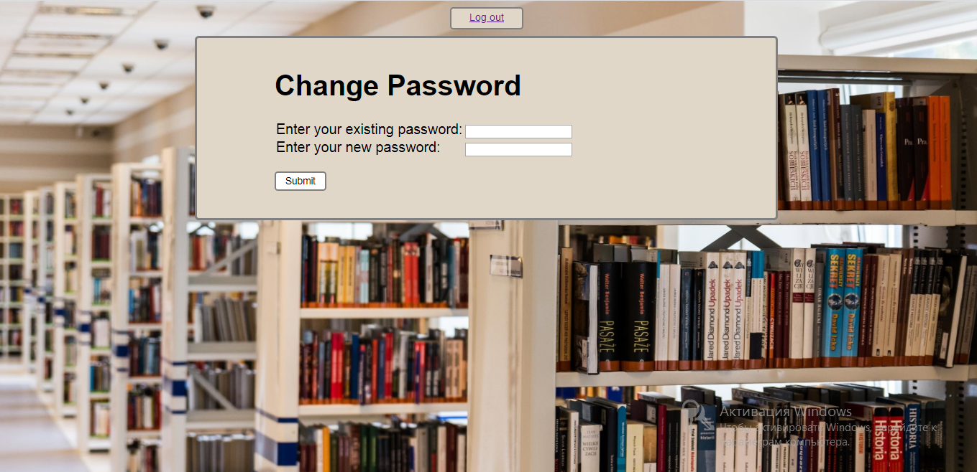

<?php

session_start();

if (isset($_POST['submit'])) {

$user_id = $_SESSION['username'];

 $old_pass = $_POST['old_pass'];

$new_pass = $_POST['new_pass'];

include("config.php");

$sql = mysqli_query($conn, "SELECT password

                                  FROM login WHERE user_name ='".$user_id."'");

while($row = mysqli_fetch_array($sql)){

$old_pass = $row['password'];

$password = $new_pass;

$hash = hash ('md5', $password);

mysqli_query($conn, "UPDATE login SET password = '".$hash."' WHERE user_name='".$user_id."'");

}

}

      ?>

When user enters data and presses the button “Submit”, the system will compare the inserted existing password with the database password (if it is correct, the system will continue) and the new inserted password will be saved in the database.

# **6.3 ins.php – Instructor main page**

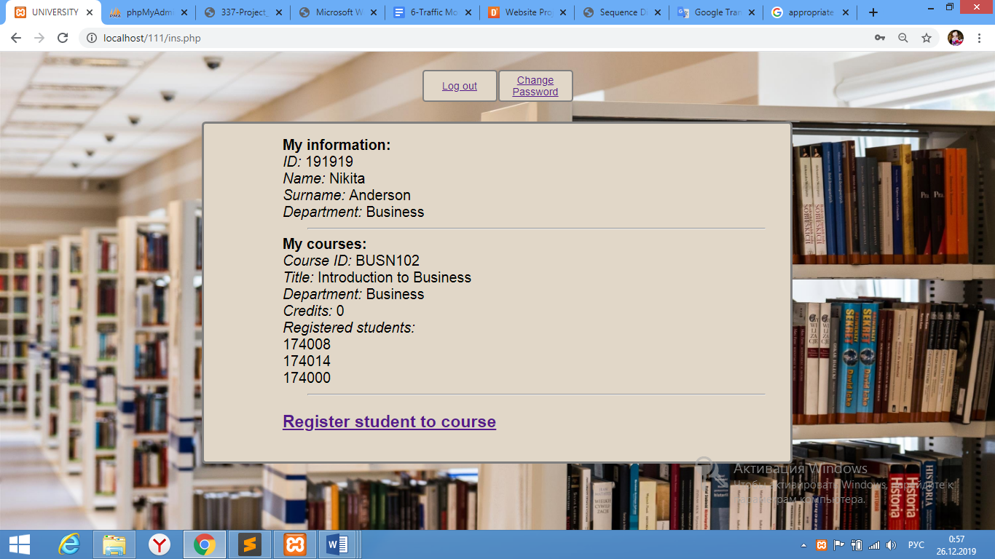

In this page instructor can see and update his/her details (change password); see the courses assigned to him/her; see course details (course info, list of students registered, etc.); register students to the courses. If instructor presses to the link “Register student to course”, the system will open “register.php” file.

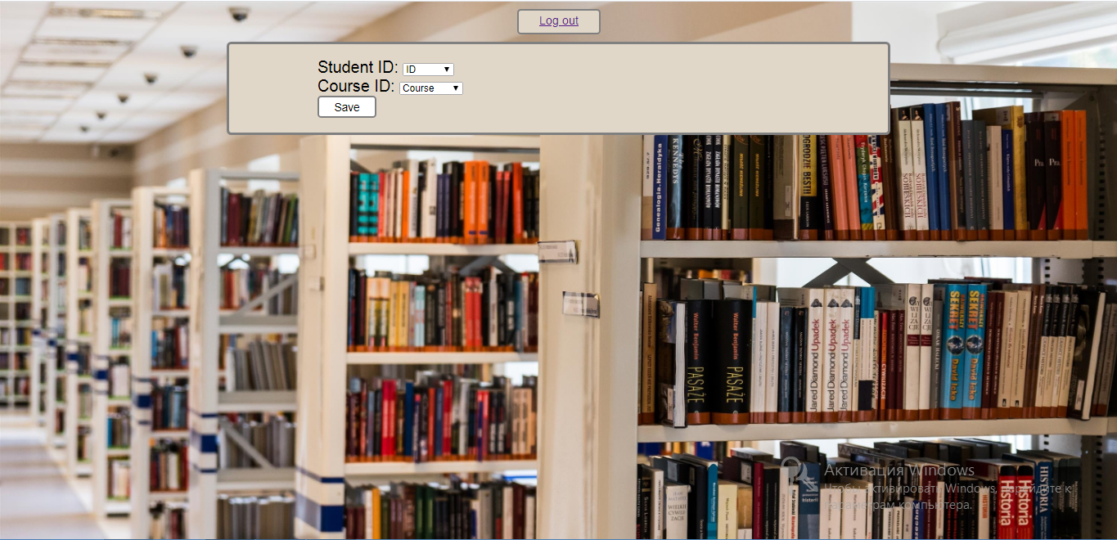

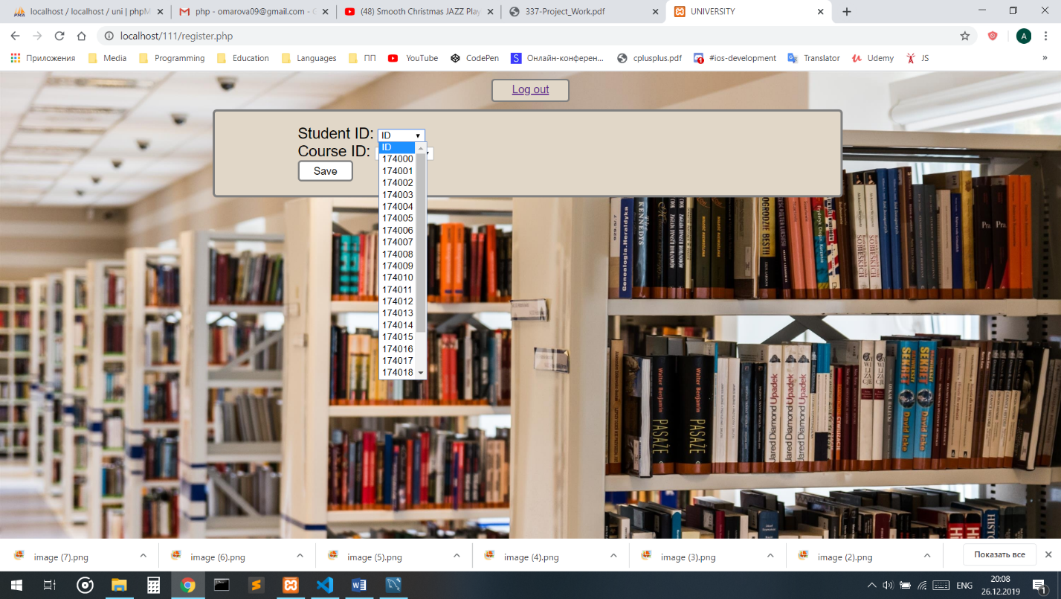

$sql1 = "select id from student order by (id) asc";

$result1 = mysqli_query($conn, $sql1);

$query = "select course_id from course order by (course_id) asc";

$result2 = mysqli_query($conn, $query);

This input list can present existing information from the database tables.

<select name = "id" value = "ID">

          <option> ID </option>

            <?php

            while($row1 = mysqli_fetch_assoc($result1)):;?>

            <option> <?php echo $row1["id"];?></option>

            <?php endwhile; ?>

        </select>

            <br/>

        <label> Course ID: </label>

        <select name = "course_id" value = "course_id">

          <option> Course</option>

        <?php

            while($row1 = mysqli_fetch_assoc($result2)):;?>

            <option> <?php echo $row1["course_id"];?></option>

            <?php endwhile; ?>

        </select>

# **6.4 fac.php – Faculty coordinator main page**

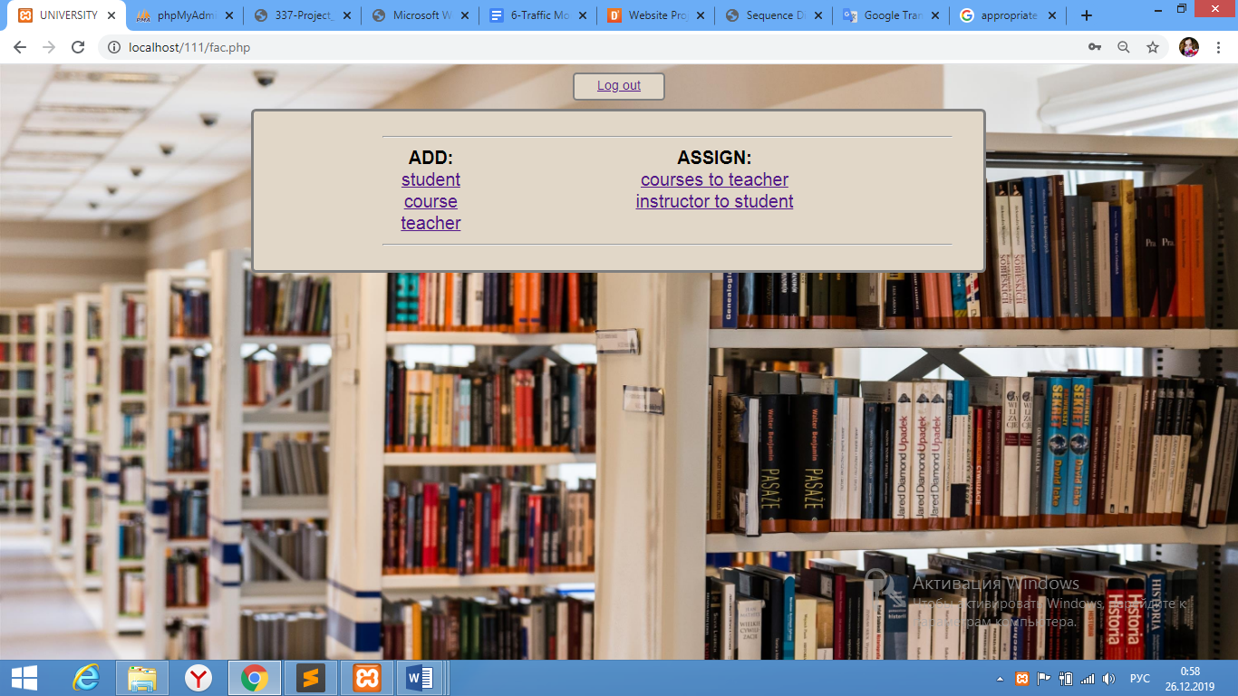

In this page coordinator can add new course, teacher, student and assign courses to instructors, instructors to students. Instructor should click on the one preferable link. When instructor presses the “Student” link, the system will open “studentAdd.php”; and same for the: “course” link – open “courseAdd.php”; “teacher” link – open “teacherAdd.php”; “course to teacher” link – opem “assign1.php”; “instructor to student” link – open “assign2.php”.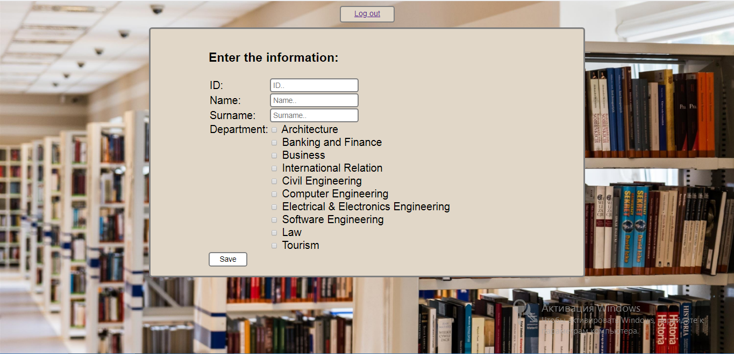

studentAdd.php

 $sql="INSERT IGNORE INTO  student(ID, fname, lname, dept_name) values ('$ID', '$fname', '$lname', '$dept_name')"  or die (mysqli_error());

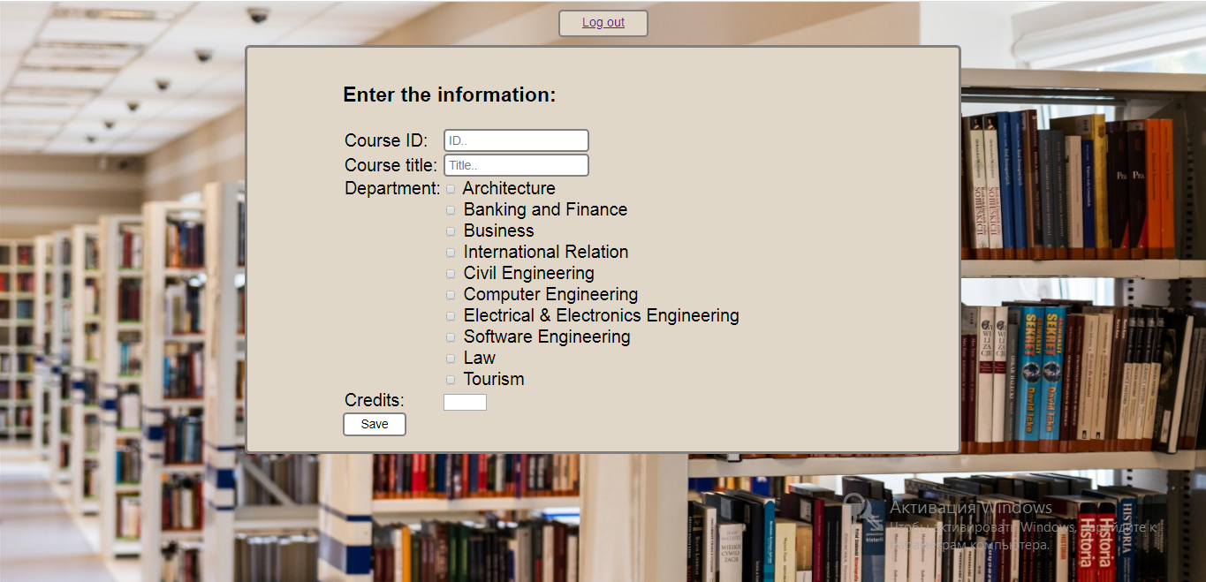courseAdd.php

$sql = "insert ignore into course(course_id, title, dept_name, credits) values  ('$course_id', '$title', '$dept_name', '$credits')" or die (mysqli_error());

teacherAdd.php

$sql="INSERT IGNORE INTO  instructor(ID, fname, lname,dept_name) values ('$ID', '$fname', '$lname', '$dept_name')"  or die (mysqli_error());

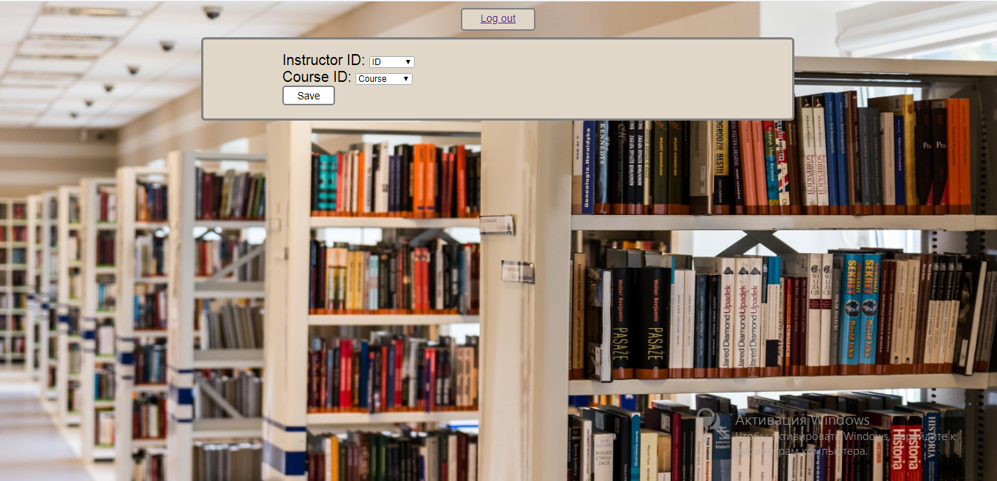

asign1.php

$sql="INSERT IGNORE INTO  teaches(ID, course_id) values ('$id', '$course_id')"  or die (mysqli_error());



assign2.php

 $sql="INSERT IGNORE INTO  advisor(s_ID, i_ID) values ('$s_ID', '$i_ID')"  or die (mysqli_error());